Lab 6 – Lambda Shared Responsibility
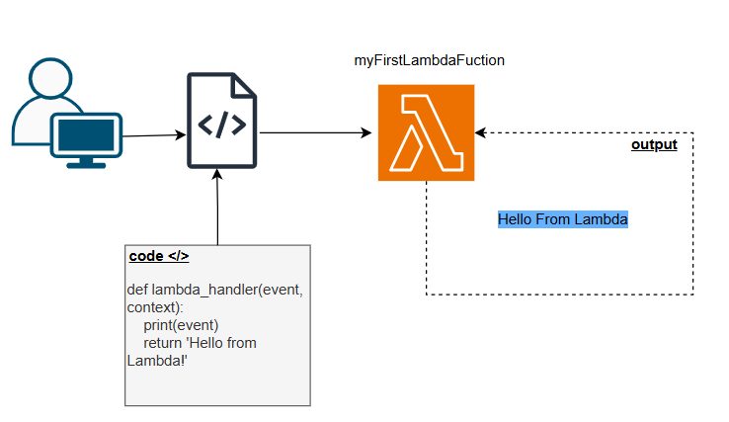

Tast 1 – Create a Lambda Fucnction
Lambda Fuction name
- myFirstLambdaFuction
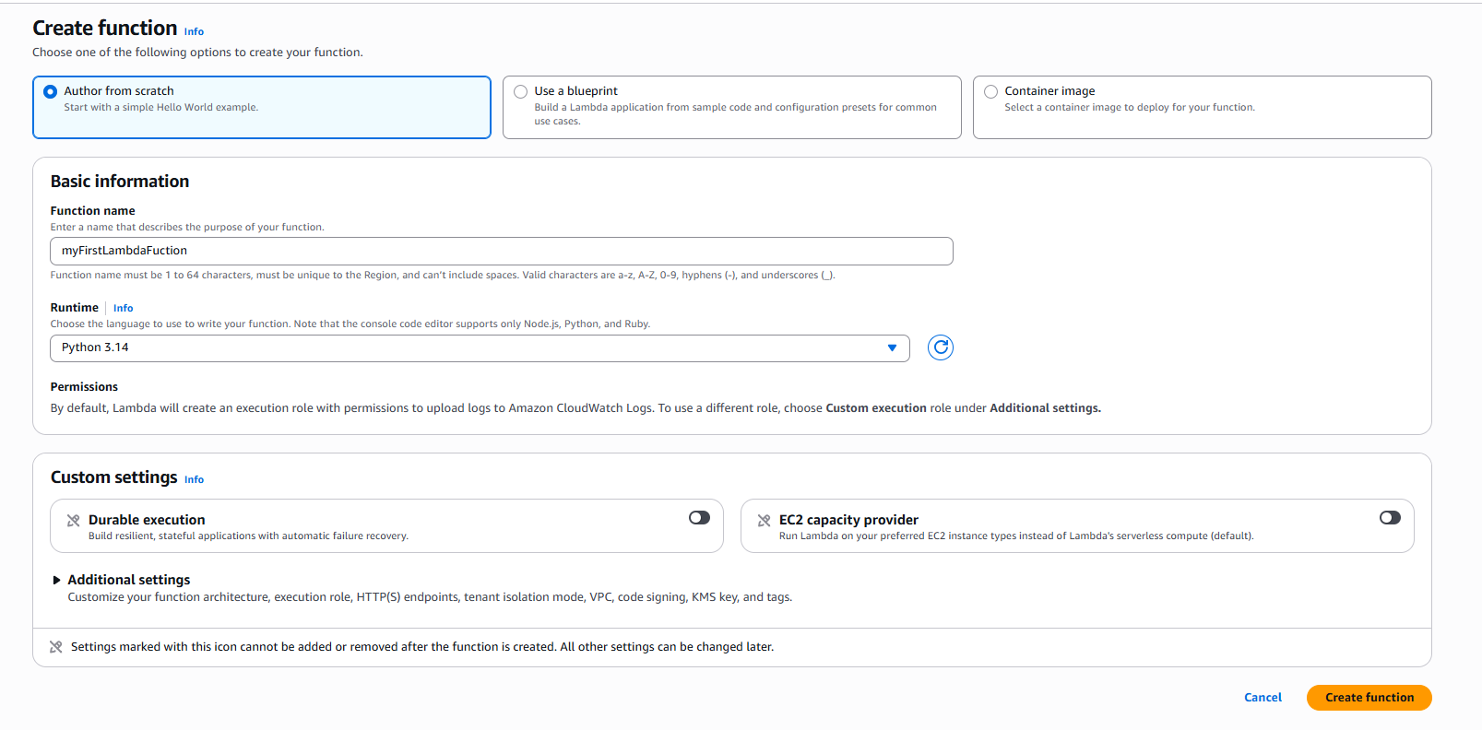

Tast 3 – Deploy a simple World Function.
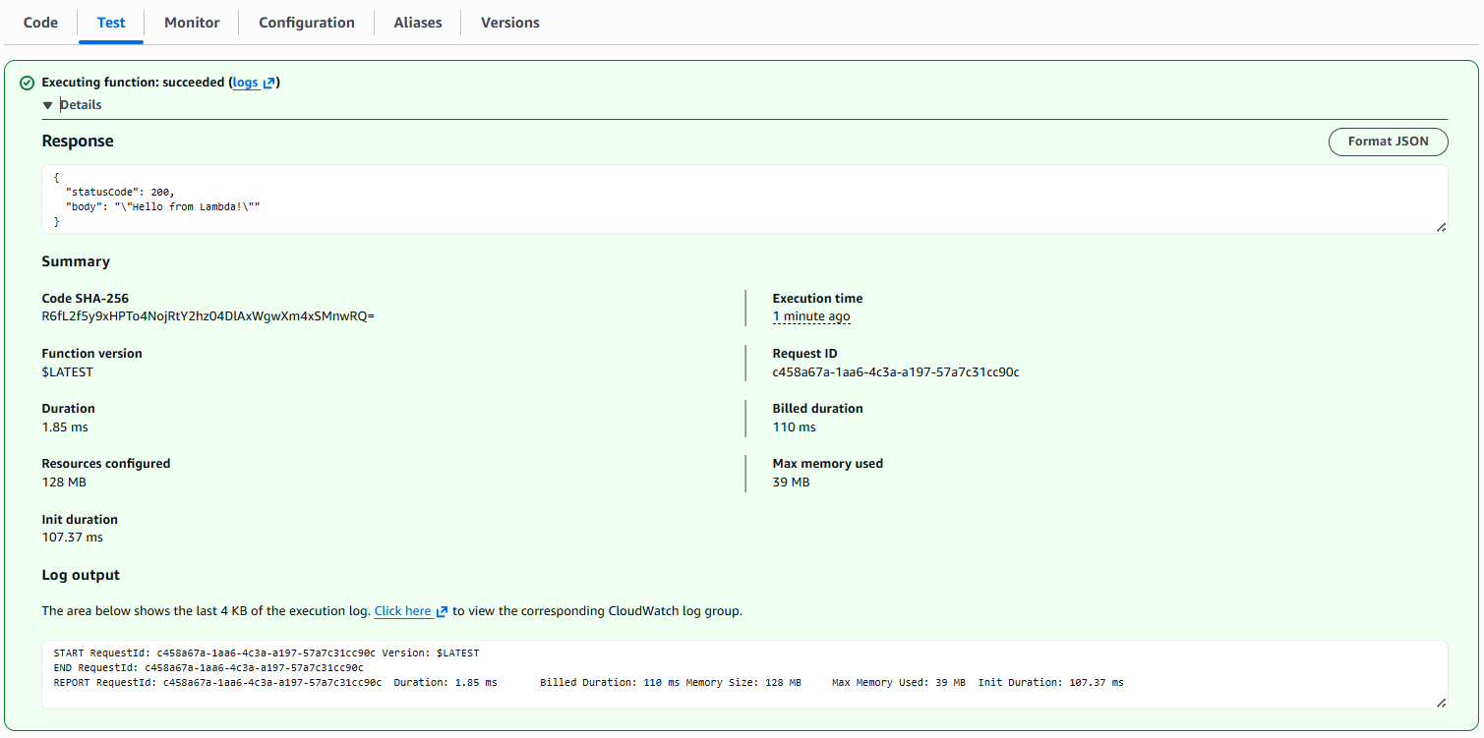

CloudWatch

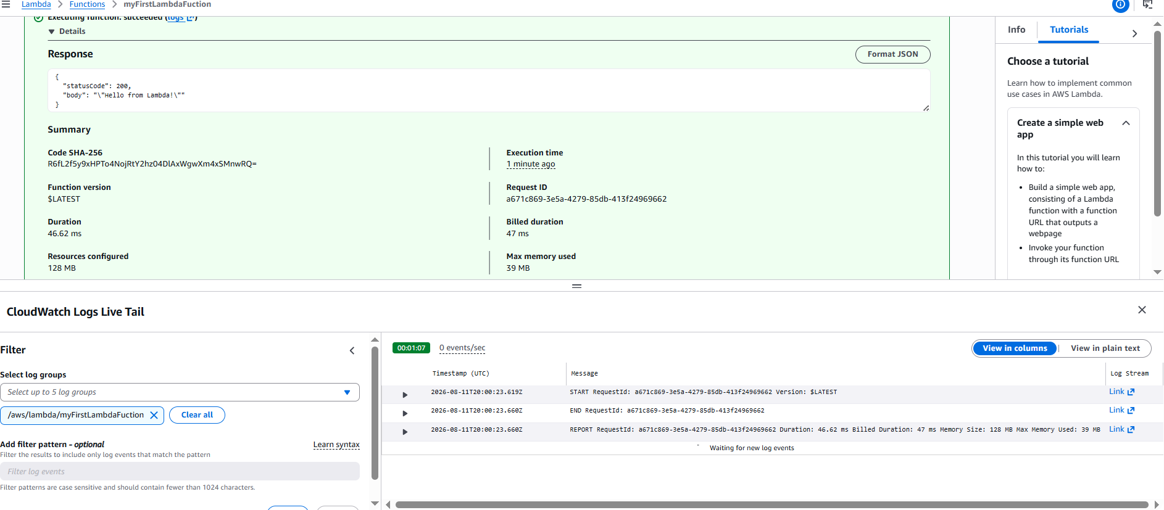

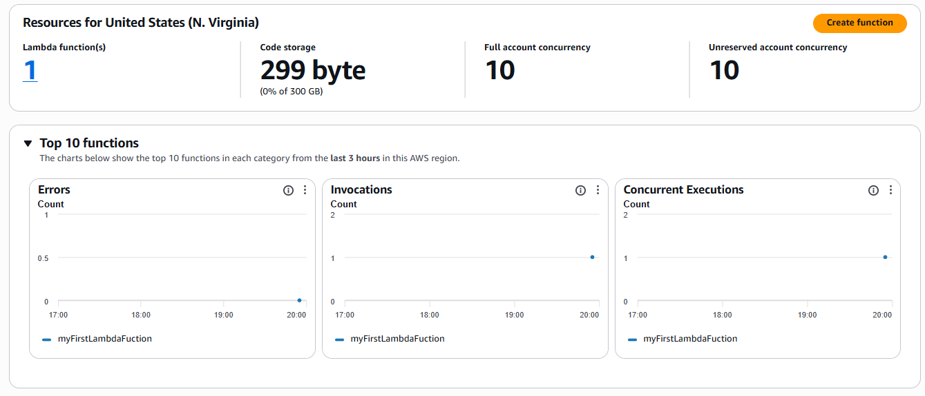
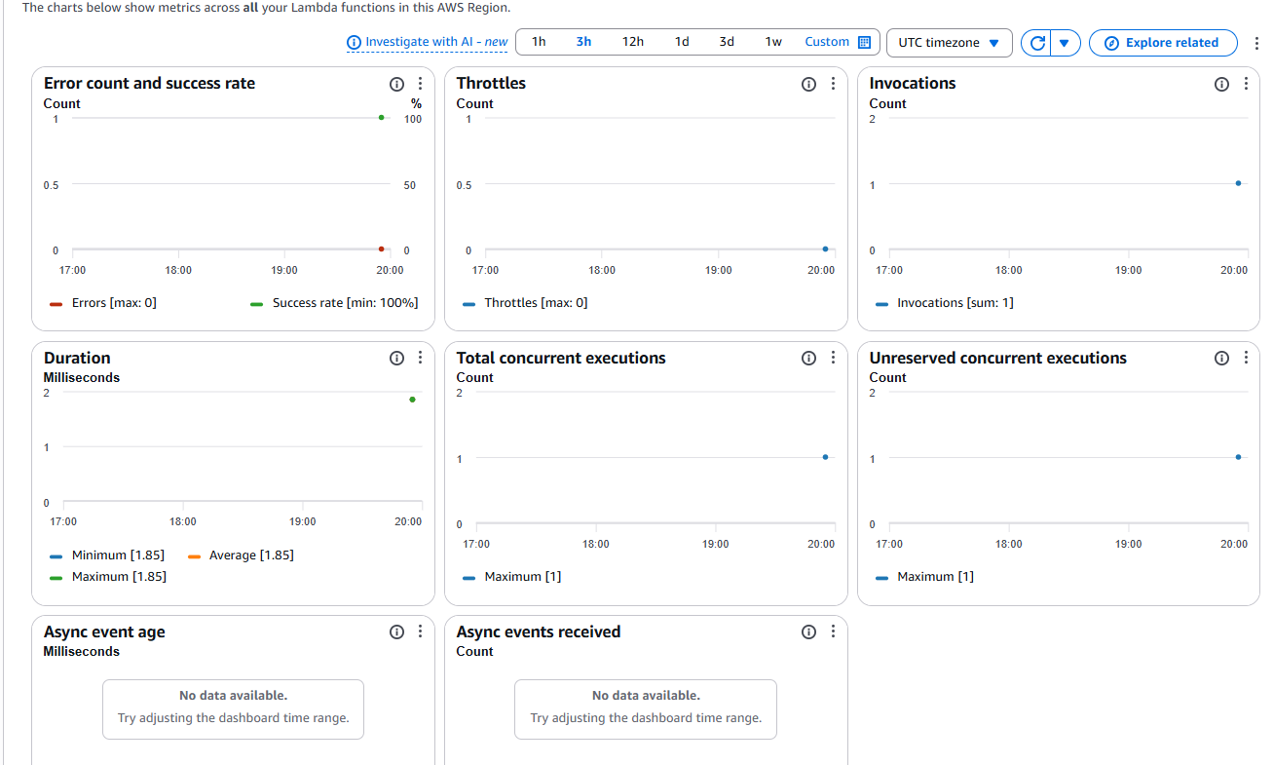
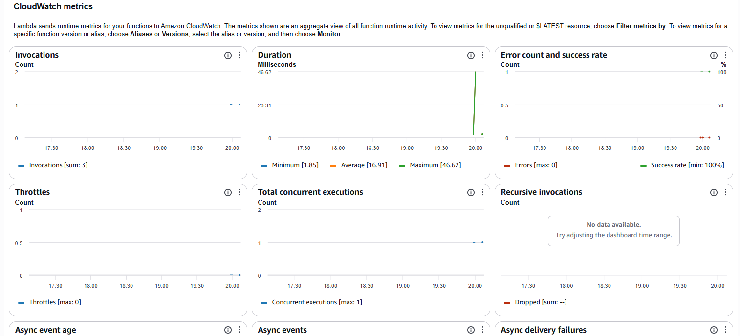

Task 4 - Identify customer Responsibilities
Responsibilities | AWS | Customer
Application Code
IAM Role
Environment Variables

